# 



**MALAD KANDIVALI EDUCATION SOCIETY’S**

**NAGINDAS KHANDWALA COLLEGE OF COMMERCE,**

**ARTS & MANAGEMENT STUDIES & SHANTABEN NAGINDAS KHANDWALA COLLEGE OF SCIENCE**

**MALAD [W], MUMBAI – 64**

**(AUTONOMOUS)**

**(Reaccredited ‘A’ Grade by NAAC)**

**(AFFILIATED TO UNIVERSITY OF MUMBAI)**

**(ISO 9001:2015)**

## CERTIFICATE

**Name: Mr./Ms. MUSTAKIM SAYYED**

**Roll No: 74 Programme**: BSc IT/CS **Semester**: II

This is certified to be a bonafide record of practical works done by the above student in the college laboratory for the course **IT platforms, Tools and Practices** (Course Code: **2026UISTP**) for the partial fulfillment of Second Semester of BSc IT/CS during the academic year 2020-2021.

The journal work is the original study work that has been duly approved in the year 2020-2021 by the undersigned



**External Examiner** **Subject-In-Charge**

**(Ms.Sweety Garg)**

**Date of Examination: (College Stamp)**

**Name: Mustakim sayyed Roll No: 74**

|  |  |  |  |
| --- | --- | --- | --- |
| **.** | **DATE** | **TITLE** | **SIGN** |
| 1. | 02/02/2021 | INTRODUCTION and CONTRIBUTING TO WIKIPEDIA  a) What is Wikipedia?  b) Steps to Create Account on Wikipedia  c) Creating Page on Wikipedia  d) Edit your page |  |
| 2. | 09/02/2021 | [Creating account, repository on GitHub and Cloning repository in GitHub Page](http://elearning.nkc.org.in:81/moodle/mod/page/view.php?id=2178) |  |
| 3. | 16/02/2021 | BASIC UNDERSTANDING ON FREE AND OPEN-SOURCE SOFTWARE   1. Describe Open-Source Software with Example. 2. Describe Free Software with Example 3. Difference between Free and Open-Source Software. |  |
| 4. | 23/02/2021 | WRITING EMAIL |  |
| 5. | 25/02/2021 | Using practical examples, describe green computing. List and explain the steps that you take to contribute to green computing |  |
| 6. | 02/03/2021 | WRITING BLOGS |  |
| 7. | 09/03/2021 | Implementing coding practices in Python using PEP8. |  |
| 8. |  | PRESENTATION: ______________________________ |  |

**Name : Mustakim Sayyed Roll no .74**

**Class .FYIT**

**{ PRACTICAL NO : 1 }**

**INDEX…**

**Introduction and Contribution to Wikipedia**

**a) Description about Wikipedia and its features**

**b) Creating Account on Wikipedia**

**c) Creating your page on Wikipedia**

**d) Editing your page on Wikipedia.**

**Introduction and Contribution to Wikipedia**

**[A] Description about Wikipedia and its features**

**Wikipedia is a free, open content online encyclopedia created through the collaborative effort of a community of users known as Wikipedians. Anyone registered on the site can create an article for publication; registration is not required to edit articles. The site's name comes from wiki, a server program that enables anyone to edit Web site content through their Web browser.**

**Jimmy Wales and Larry Sanger co-founded Wikipedia as an offshoot of an earlier encyclopedia project, Nupedia, in January 2001. Originally, Wikipedia was created to provide content for Nupedia. However, as the wiki site became established it soon grew beyond the scope of the earlier project. As of January 2015, the website provided well over five million articles in English and more than that number in all other languages combined. At that same time, Alexa ranked Wikipedia as the seventh-most popular site on the Internet. Wikipedia was the only non-commercial site of the top ten. { Wikipedia Homepage }**

**Criticisms of Wikipedia include assertions that its openness makes it unreliable and unauthorative. Because articles don't include bylines, authors aren't publicly accountable for what they write. Similarly, because anyone can edit any article, the site's entries are vulnerable to unscrupulous edits. In August 2007, Virgil Griffiths created a site, Wikiscanner, where users could track the sources of edits to Wikipedia entries. Griffiths reported that self-serving edits typically involved whitewashing or removal of criticism of a person or organization or, conversely, insertion of negative comments into the entry about a competitor. Wikipedia depends upon the vigilance of editors to find and reverse such changes to content.**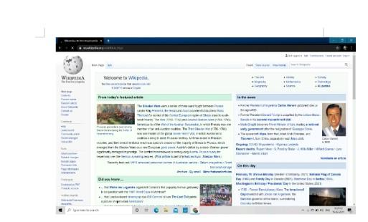

**Features of Wikipedia :**

**1. Wikis can be edited by multiple approved people.**

**2. All edits are tracked in the page’s history.**

**3. Linking between pages on a wiki is very simple.**

**4. Pages are automatically placed in a list of all pages.**

**5. A recent changes page shows all edits made to the wiki.**

**6. Any bad edits can be easily reverted**

**7. Note taking.**

**8. Knowledge management.**

**9. Community Websites.**

**10. Intranets.**

**b) Creating Account on Wikipedia:**

**Go to www.wikipedia.org and choose "English"**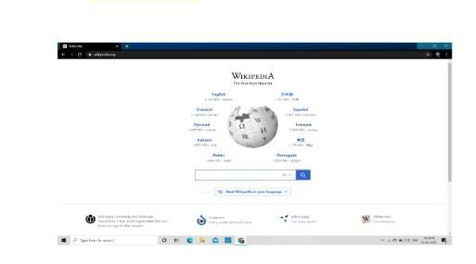

**Click "Create account" on the upper right side of your browser**



**Click here to create account**

**Enter your account information and the captcha, and click "Create Account".**

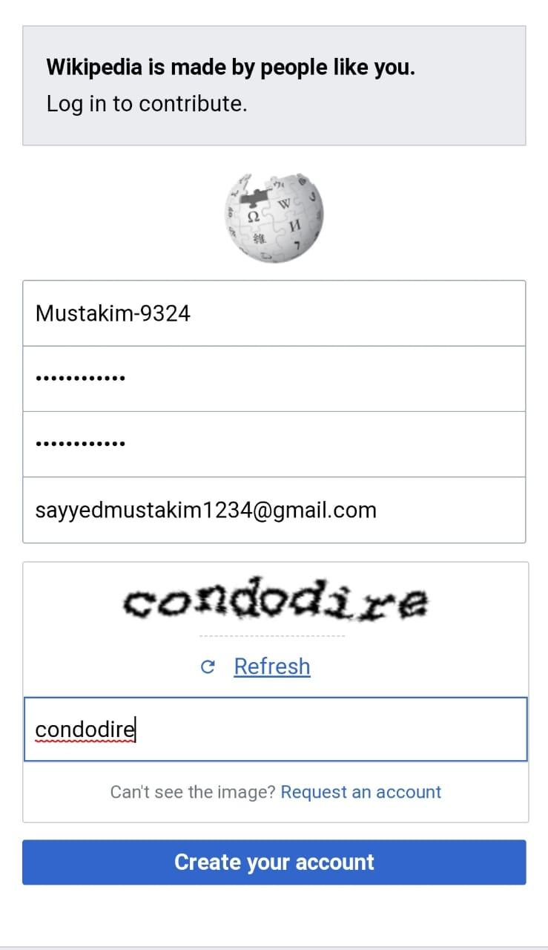**After creating account this page will appear:**

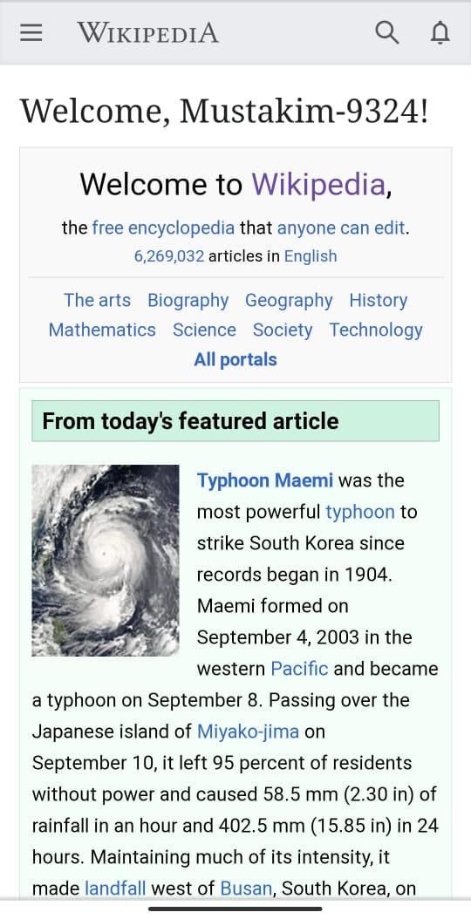

**c) Creating your page on Wikipedia:**

**1. To create a Wikipedia.org page, you must have a registered account. Log in or create one.**

**2. Click on your account**

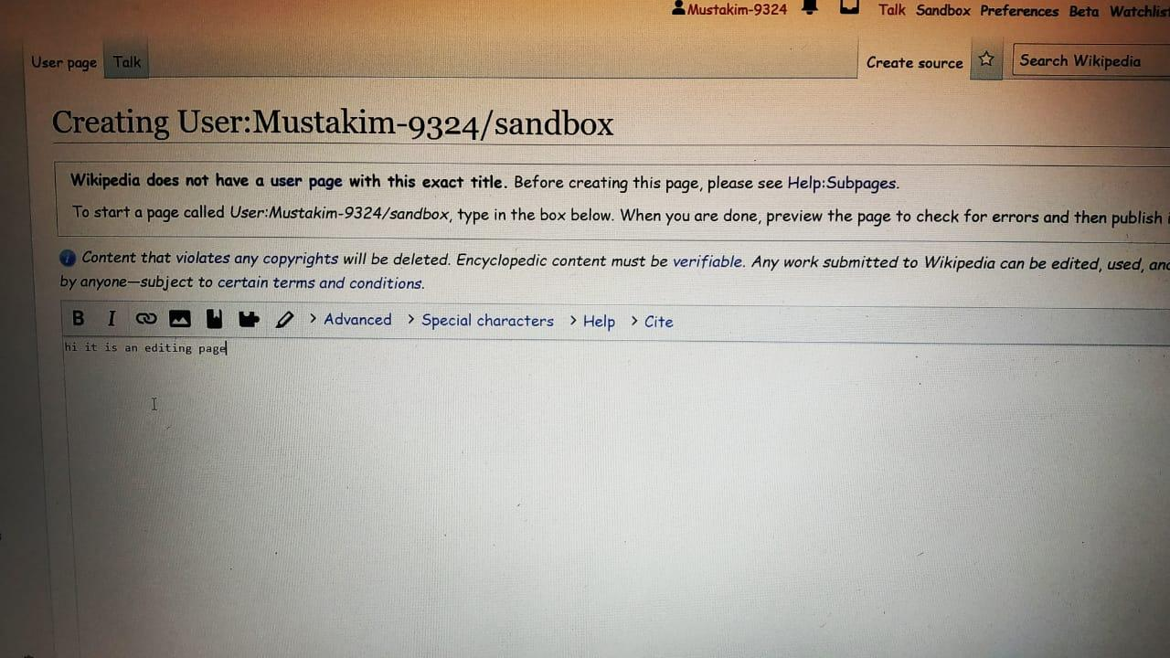

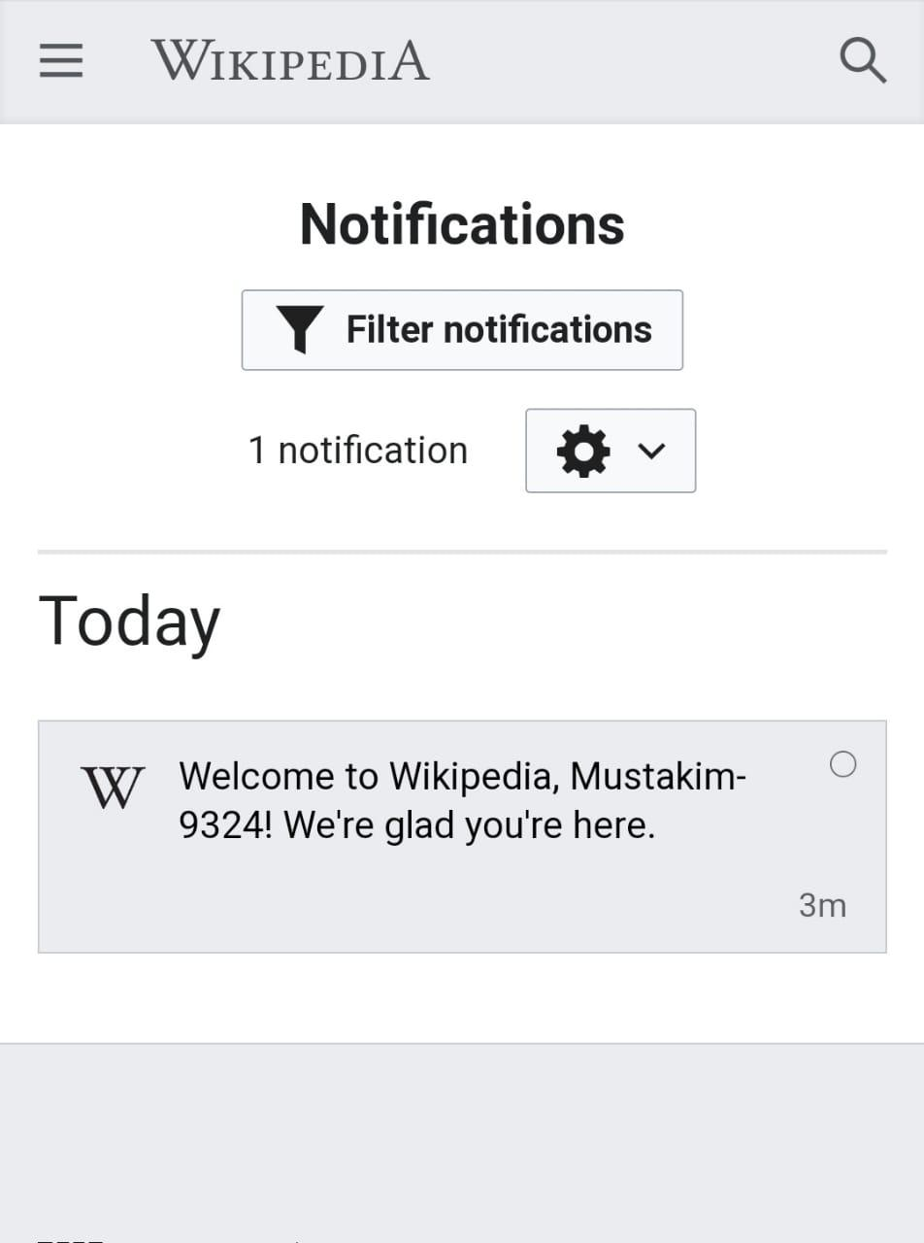**5. You have to write the content you want in your Wikipedia page as shown in the image below**

**5. You have to write the content you want** 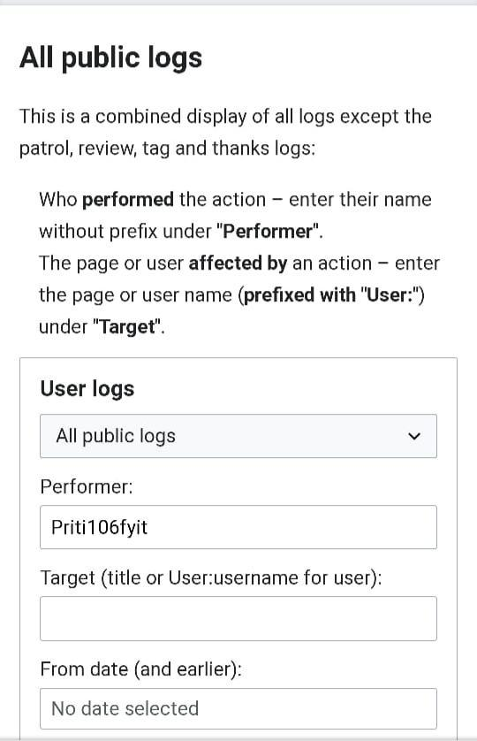

**Click the view history then will appear history page**

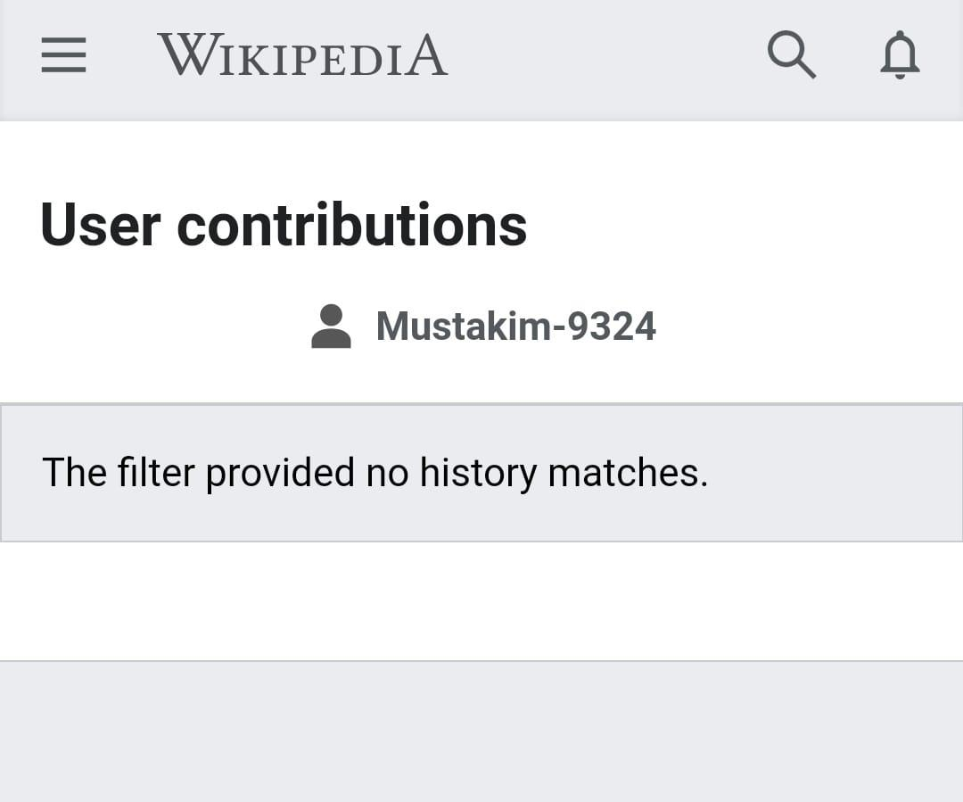

**d) Editing your page on Wikipedia:**

**1)Go to the page you want to edit**

**2) Click on edit source**

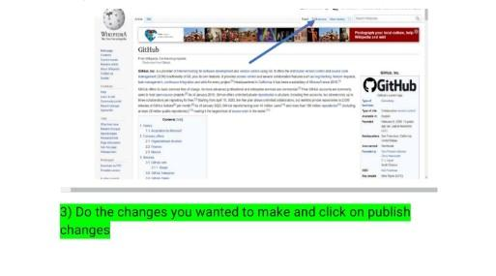

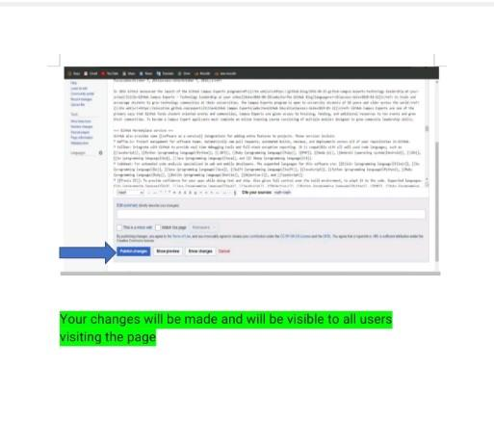

**PRACTICAL NO : 2**

**INDEX….**

**1) CREATING ACCOUNT IN GITHUB**

**2) CREATING A REPOSITORY**

**3) CLONING REPOSITORY**

**AIM : Creating account, repository and cloning repository in github.**

**#1) CREATING ACCOUNT IN GITHUB.**

**[Step 1] : Type GitHub login in any browser and search it and then click on official github link. After that Github login page will appear then click on Create an account Option.**

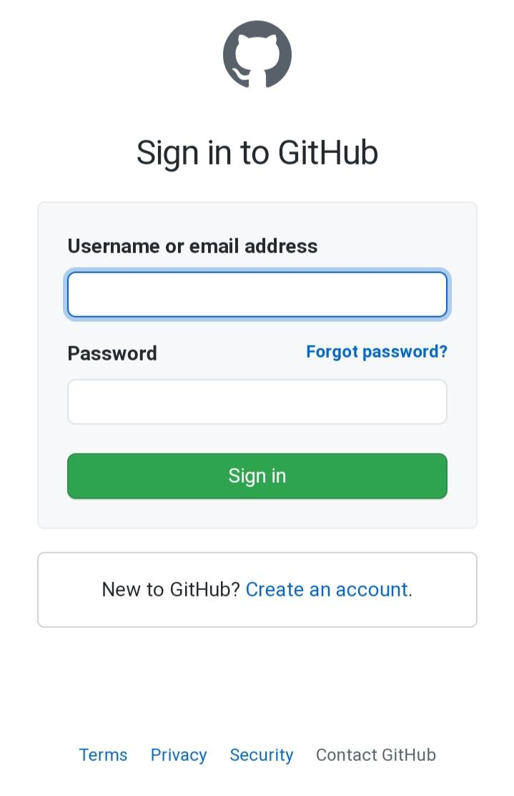

**CLICK HERE TO CREATE NEW ACCOUNT IN GITHUB.**

**Step 2 : Now enter username ,Email id and set password for your account and then click on verify account and solve the captcha ( it will ask three times to solve the given task) and after that click on the create account.**

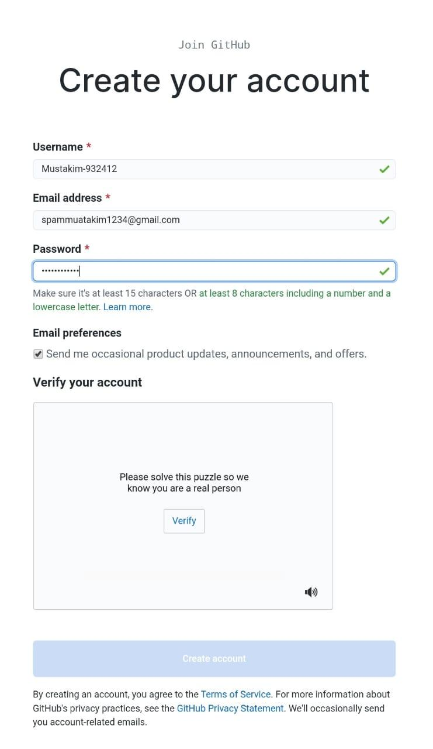

**AFTER ENTERING USERNAME PASSWORD AND COMPLETING CAPTCHA CLICK ON CREATE ACCOUNT.**

**STEP 3 : After clicking on the create account you will receive a mail on your email account which you have entered while the creating account for verification. Now you have to just click on the mail and then enter the username and password after completing this your account will be verified.**

**CLICK HERE AND IT WILL ASK TO LOGIN THEN ENTER THE USERNAME AND PASSWORD THEN CLICK ON LOGIN. AFTER COMPLETING THIS YOUR ACCOUNT WILL BE VERIFIED SUCCESSFULLY.**

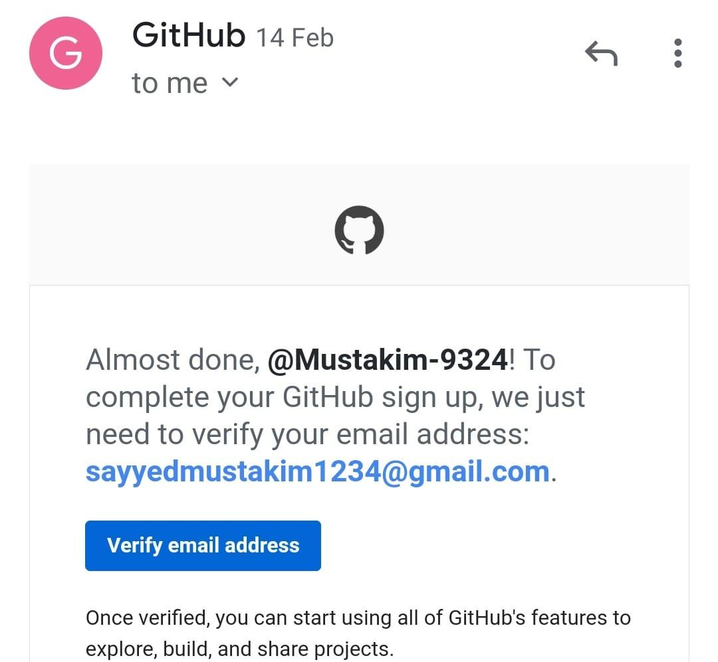

**2) CREATING A REPOSITORY.**

**STEP 1: To create a repository click on create**

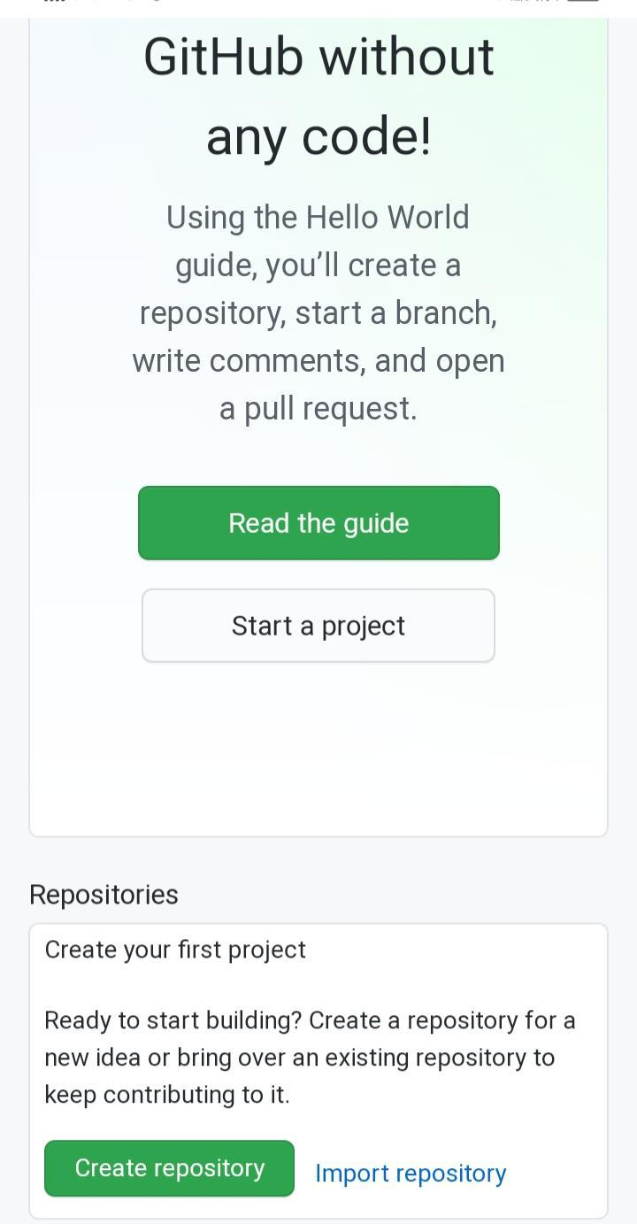

**CLICK HERE TO CREATE NEW REPOSITORY**

**STEP 2 : Enter repository name and description. Also you will have to option PUBLIC (by selecting this option your repository will be visible to everyone) and PRIVATE (by selecting this option your repository will not be visible to others). And you can also add a readme file, gitignore and license. after selecting Option according to your choice click on Create Repository Option.**

**NOW THE NEW REPOSITORY IS CREATED .**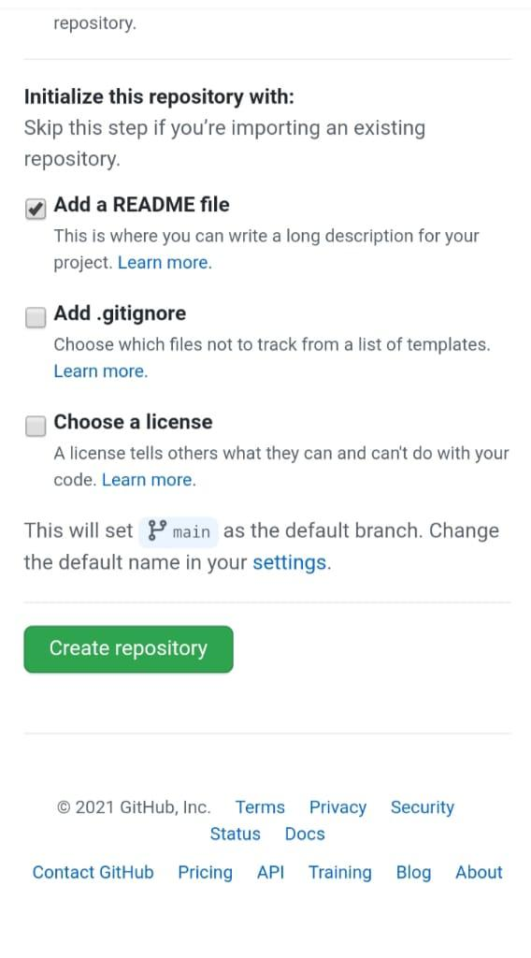

**3) Cloning a Repository**

**STEP 1: Click on the CODE option**

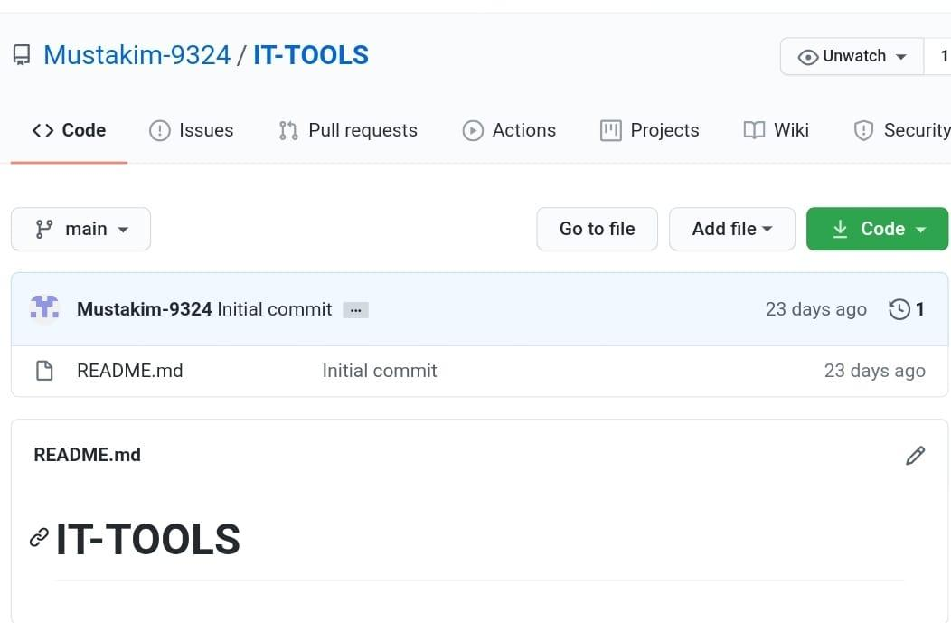

# PRACTICAL 3

BASIC UNDERSTANDING ON FREE AND OPEN-SOURCE SOFTWARE

1. Describe Open Source Software with Example.

Definition:

* + A software for which the original source code is made freely available and may be redistributed and modified according to the requirement of the user.
  + Open source software is that by which the source code or the base code is usually available for modification or enhancement by anyone for reusability and accessibility.
  + Open source code is the part of software that mostly users don't ever see.
  + Anyone can manipulate and change a piece of software so that the program or application can work. Programmers who have access to a computer program source code can improve a program by adding features to it or fixing parts that don't always work correctly.

Description:

* + There are two kinds of software. One is open source software and the other is proprietary software or closed source software.
  + As the source code of an open source program can be modified by anyone without any licence to do the same, this is also free to download.
  + The terms of use are often defined by the General Public Licence, which serves as the Software Licence Agreement (SLA) for many open source programs.
  + Many people prefer open source software because they are interested in more control over these kinds of software.
  + They can examine the code to make sure it's not doing anything they don't want it to do, and they can only change parts of it they don't like to do.
  + Generic users who aren't programmers also took benefit from open source software, because they can use this kind of software for any purpose without any prior notice to the proprietor as they wish—not merely the way someone else thinks they should.
  + This is a common misconception about what open source implies. Generally programmers can’t charge money for the open source software they create or to which they contribute.

1. Describe Free Software with Example

Definition:

* + Free software means software that respects users' freedom and community. Roughly, it means that the users have the freedom to run, copy, distribute, study, change and improve the software.
  + Thus, “free software” is a matter of liberty, not price. To understand the concept, you should think of “free” as in “free speech,” not as in “free beer”.
  + We sometimes call it “libre software,” borrowing the French or Spanish word for “free” as in freedom, to show we do not mean the software is gratis.

The four essential freedoms :

* + The freedom to run the program as you wish, for any purpose
  + The freedom to study how the program works, and change it so it does your computing as you wish (freedom 1). Access to the source code is a precondition for this.
  + The freedom to redistribute copies so you can help others
  + The freedom to distribute copies of your modified versions to others
  + By doing this you can give the whole community a chance to benefit from your changes. Access to the source code is a precondition for this.

1. Difference between Free and Open Source Software.

|  |  |
| --- | --- |
| Open Source | Free Source |
| Open source is a development methodology | Free software is a social movement |
| Open source has a distribution of licence | Freedom to run program for any purpose |
| Open source just has the availability of source code | Free software gives freedom to study about there code |
| Open source can be distributed freely | It allows user to distribute the copies |
| Open source have an integrity of authors source code | Freedom to modify the program and distribute in public |

Practical no – 4

WRITING EMAIL

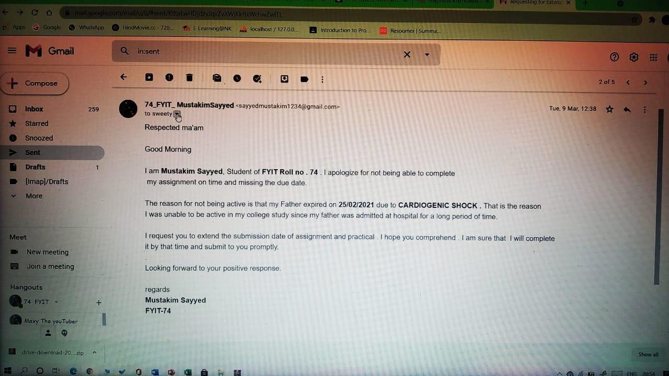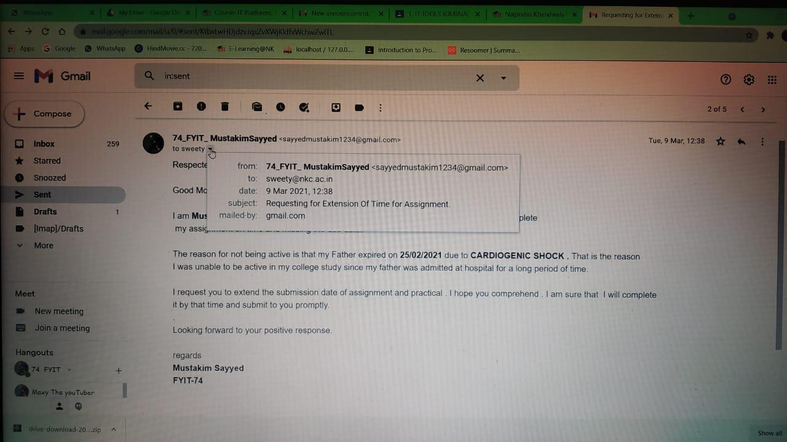

Practical no: 5

1. Using practical examples, describe green computing. List and explain the steps that you take to contribute to green computing.

Green computing –

Green computing is the environmentally responsible and eco-friendly use of computers and their resources. In broader terms, it is also defined as the study of designing, manufacturing/engineering, using and disposing of computing devices in a way that reduces their environmental impact.

**Green computing**, **green ICT** as per International Federation of Global & Green ICT "IFGICT", **green IT**, or **ICT sustainability**, is the study and practice of [environmentally sustainable](https://en.wikipedia.org/wiki/Environmentally_sustainable) computing or IT.

The goals of green computing are similar to [green chemistry](https://en.wikipedia.org/wiki/Green_chemistry): reduce the use of hazardous materials, maximize [energy efficiency](https://en.wikipedia.org/wiki/Efficient_energy_use) during the product's lifetime, the [recyclability](https://en.wikipedia.org/wiki/Recycling) or [biodegradability](https://en.wikipedia.org/wiki/Biodegradation) of defunct products and factory waste.

Green computing is important for all classes of systems, ranging from handheld systems to large-scale data centers. Many corporate IT departments have green computing initiatives to reduce the environmental effect of their IT operations.

1. List and explain the steps that you take to contribute to green computing.

1. Buy "Energy Star" labeled monitors, desktops, laptops, and printers . The "Energy Star" devices can be programmed to "power-down" to a low power state when they are not in use, helping you save energy and run cooler which helps them last even longer. The Energy Star specification for computers was revised on October 20, 2006 and goes into effect July 20, 2007. The specification includes new performance requirements to qualify for the Energy Star rating for desktop and notebook computers, workstations, integrated computers, desktop-derived servers and game consoles. Now you can feel good about that upgrade!

2. Put laptops in "sleep" mode when not in use. [The EPA has estimated](http://ecenter.colorado.edu/energy/projects/green_computing.html) that this reduces their energy use by 60 to 70 percent – and ultimately could save enough electricity each year to power Vermont, New Hampshire, and Maine, cut electric bills by $2 billion, and reduce carbon dioxide emissions by the equivalent of 5 million cars.

3. Even better, turn OFF computers and other equipment when not in use. Despite the debate over whether it's better for your computer to be left on or shut off, the fact is it's better for the environment to shut it off. Trust me, your computer can handle it just fine; in fact, computers were designed to be turned off and back on!

4. E-cycle used computer equipment. [Find a recycler in your area](http://www.eiae.org/). Also, Staples, the office supply retailer, has now started a recycling program. They will accept any brands of used desktop and notebook computers, monitors, printers, fax machines and all-in-one devices with a fee of $10. Smaller items like keyboards, mice and speakers are free to drop off.

5. [Buy the new "Smart Strip" power strip](http://www.smarthomeusa.com/Shop/Bits-Ltd./Item/LCG4/). The Smart Strip actually senses how much power your computer peripherals use. And when the Smart Strip senses that you've turned your computer off, it automatically shuts off your peripherals, too, preventing them from drawing an idle current, which is the current drawn even after equipment is shut off.

Practical no – 6

WRITING BLOGS

Link:- “https://informationhubcenter.blogspot.com/2021/03/uttarakhand-cm-tirath-sing-rawat-has.html”

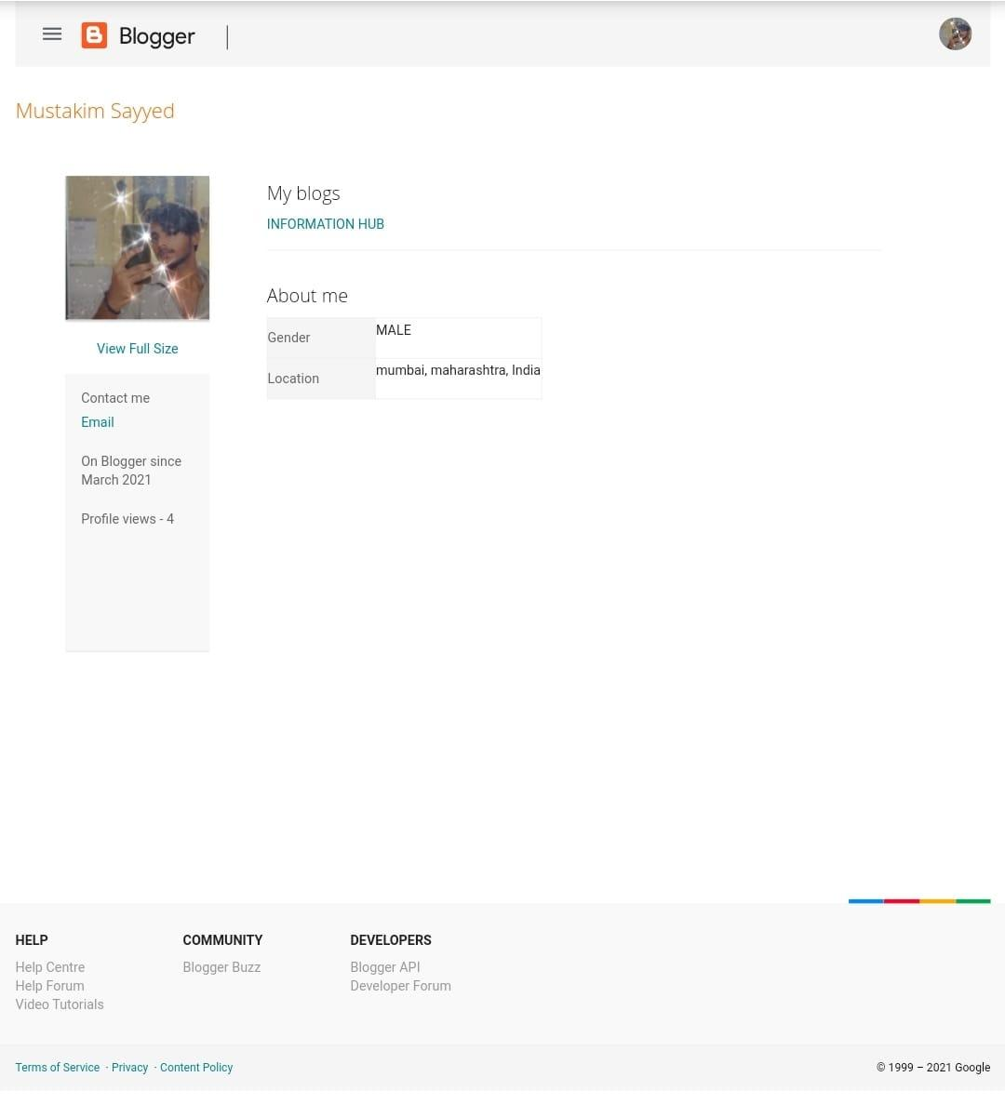

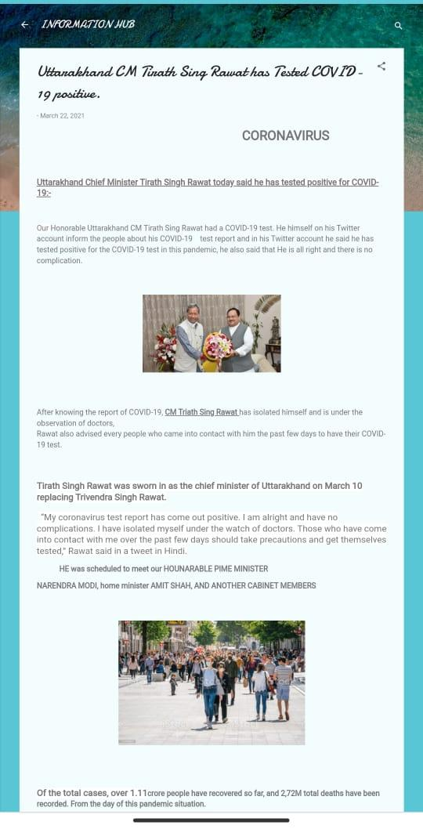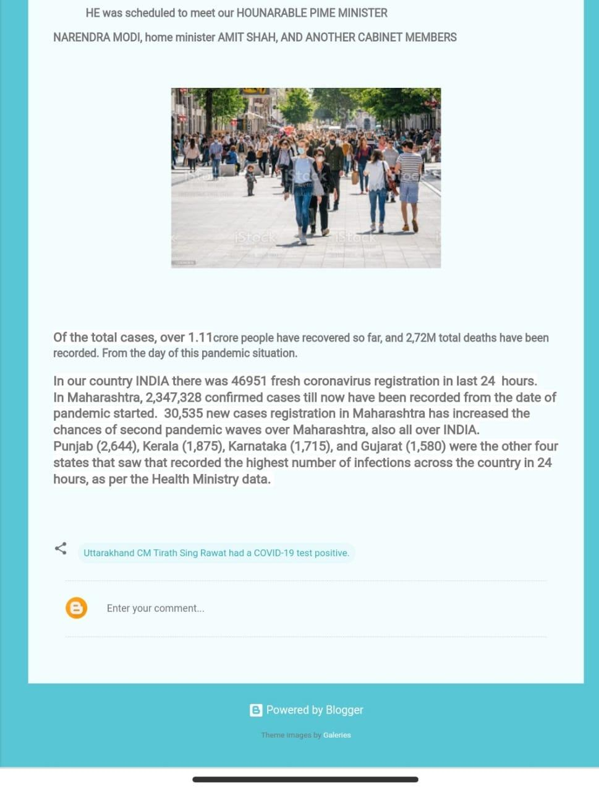

Practical no – 7

Implementing coding practices in Python using PEP8.

* PEP 8, sometimes spelled PEP8 or PEP-8, is a document that provides guidelines and best practices on how to write Python code. It was written in 2001 by Guido van Rossum, Barry Warsaw, and Nick Coghlan. The primary focus of PEP 8 is to improve the readability and consistency of Python code.
* PEP stands for Python Enhancement Proposal, and there are several of them. A PEP is a document that describes new features proposed for Python and documents aspects of Python, like design and style, for the community.

## The Code Layout

Your code layout has a huge impact on the readability of your code.

### Indentation

The indentation level of line is computed by the leading spaces and tabs at the beginning of a line of logic. It influences the grouping of statements.

The rules of PEP 8 says to use 4 spaces per indentation level and also spaces should be preferred over tabs.

An example of code to show indentation:

x = 5

if x < 10:

  print('x is less than 10')

Need of PEP8 –

Readability is the key to good code. Writing good code is like an art form which acts as a subjective topic for different developers.

Readability is important in the sense that once you write a code, you need to remember what the code does and why you have written it. You might never write that code again, but you’ll have to read that piece of code again and again while working in a project.

PEP 8 adds a logical meaning to your code by making sure your variables are named well, sufficient whitespaces are there or not and also by commenting well. If you’re a beginner to the language, PEP 8 would make your coding experience more pleasant.

Example:-

def calculate_average(number_list):

    sum_list = 0

    for number in number_list:

        sum_list = sum_list + number

    average = 0

    average = sum_list / len(number_list)

   return average

PRESENTATION



WHAT IS INTRANET ?

* (Sparsh/krish.c)

▪DEFINATION:-An intranet is a private enterprise network, designed to support an organization’s employees to communicate, collaborate and perform their roles. It serves a broad range of purposes and uses, but at its core, an intranet is there to help employees.

INTRANET MEANING!

* *Intranet is defined as private network of computers within an organization with its own server and firewall.
* *Moreover we can define Intranet as:Intranet is system in which multiple PCs are networked to be connected to each other.
* * PCs in intranet are not available to the world outside of the intranet.
* *Usually each company or organization has their own Intranet network and members/employees of that company can access the computers in their intranet.
* *Every computer in internet is identified by a unique IP address.Each computer in Intranet is also identified by a IP Address, which is unique among the computers in that Intranet.

INTRANET.



* Why we use it ?

▪

* (AniketShukla)

USE OF INTRANET!

* Increased productivity for your teams :
* An intranet can: reduce email use; allow for quicker responses on small to medium issues; make information easy to find; give your team access to all the tools and information they need to effectively perform in their role.
* • Easy collaboration :
* Whether your team are in the same location or not, an intranet makes it possible for your team to: communicate freely; easily exchange ideas; share documents with one another.

INTRANET USES!

* An engaged, connected workforce :
* A well-designed and modern intranet transforms the employee experience to promote efficiency, growth, innovation and connectedness – all key ingredients of an engaged workforce.
* Secure knowledge management :
* An intranet provides one central place to store all your company documents, that are always up-to-date and can be accessed by anyone on your team.

USES OF INTRANET!

* Strong company culture :
* Easy collaboration and communication fosters an environment for your team to interact and get to know one another, especially if you incorporate a social element into your intranet.

TECHNOLOGY BEHIND INTRANET?

# (MEET)

▪ *One or more inter-connected TCP/IP network.

▪

THE TCP/IP PROTOCOL SUITEThe protocol stack used on the Internet is the

Internet Protocol Suite. It is usually called TCP/IP after two of its most prominent protocols, but there are other protocols as well. The TCP/IP model is based on a five-layer model for networking. From bottom (the link) to top (the user application), these are the physical, data link, network, transport, and application layers. Not all layers are completely defined by the model, so these layers are “filled in” by external standards and protocols. The layers have names but no numbers, and although sometimes people speak of “Layer 2” or “Layer 3,” these are not TCP/IP terms. Terms like these are actually from the OSI Reference Model

TECHNOLOGY BEHIND INTRANET!

▪Internet connectivity with firewall protection Servers:

Web, E-Mail, Proxy, DNS

▪Mozilla and the Firefox browser extension developer community have created a range of tools that can simplify and speed up your browser extension development. This page provides a summary of those tools including details on the features each offers, how to get started, where in the development cycle it fits, and links to useful resources.

ADVANTAGES OF INTRANET!

(ROSHINI)

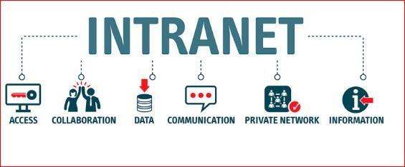

ADVANTAGES OF INTRANET!

❖ COST EFFECTIVE :

▪

▪ The expense of communicating infoRMATION ▪ USING INTRANET IS EXTREMELY LOW .

❖ AVAILABILITY :

* By using intranet employees can access
* their information anytime and anywhere.

ADVANTAGES!

❖INFORMATION EXCHANGE :

* INTRANET CAN BE USED AS A COMMUNICATION HUB
* WHERE EMPLOYEES STORE INFORMATION WHENEVER

THEY

* WANTED .

❖ WEB PUBLISHING :

* ALL THE INFORMATIONS CAN BE VIEWED VIA WEB BROWSER.

INTRANET ADVANTAGES.

❖DECISION MAKING :

* FOR AN EFFECTIVE DECISION MAKING THERE ▪ SHOULD BE ADEQUATE INFORMATIONS AVAILABLE .

❖ COLLABORATION :

▪ ANOTHER BENEFIT OF INTRANET IS THE LEVEL OF ▪ COLLABORATION IT PROVIDES .

Disadvantage of intranet.

# (VIVEK)

DISADVANTAGES OF INTRANET!

▪Implementation and complexity

* The cost of implementing intranets are usually high (Depending on the type of intranet solutions and the number of users). Additionally it needs separate training and upgrade for using the intranet solution effectively. All these require time and effort which makes it difficult the implementation process.

Intranets are considered to be complex in nature. Due to their complexity many employees feel overwhelmed and unwilling to use it. And also intranet users needs to do separate administration which can be time consuming.

SECURITY AND ONBOARDING.

* Al though intranet systems doe contain many security measures, it is still vulnerable to security risks. Unless there are firewalls or gateways, your private informations can be accessed by a third party. Therefore, when using intranet there is a loss of privacy for the corporates.
* In intranet always the employees should be satisfied at the point of launch. If there are no valued content, staff will not use it anymore. Therefore, content plays an important role here.

UPDATES OF INTRANET.

▪An intranet solution that gets frequently updated is less prone to usability issues. But the problem remains in finding one. It can be extremely challenging to find an intranet solution that remains updated. These kinds of intranet systems most at times lack customer support. Hence, employees of the company will have a problem adopting to it.

HISTORY OF INTRANET!

(STUTI)

▪ In accordance to sources, the birth of the intranet fell on a 1994 – 1996, that was true prehistory from an IT systems point of view. Intranet history is bound up with the development of Internet – the global network. The idea of WWW, proposed in 1989 by Tim Berners-Lee and others, which aim was to enable the connection and access to many various sources, became the prototype for the first internal networks. The goal of intranet invention was to increase employees productivity through the easier access to documents, their faster circulation and more effective communication. Although, access to information was always a crucial matter, in fact, intranet offered lots more functionalities, i.e.: e-mail, group work support, audio-video communication, texts or personal data searching.

DIFFFERENCEBETWEEN INTRANET AND INTERNET.

(HARSH)

* The Internet is a global system of computer networks available for everyone, whereas Intranet is a network of computers owned by any organization for a certain group of people.A
* The Internet is a public network, while Intranet is a private network.
* The total number of users using the Internet is very high, whereas total users on Intranet are limited.
* Information on the Internet is broad that involves almost every topic, category and field. In contrast, Intranet includes limited information that refers to any group or organization, such as the company's databases.
* The Internet can be accessed and used by anyone, whereas the Intranet is limited to organization employees or admin with login details.
* The Internet is a public network that is not considered safe, while the Intranet is a safer network.
* The intranet is usually owned by a firm, institution, or organization, but any single person or an organization does not own the internet

DIFFERENCE BETWEEN INTRANET AND

EXTRANET.

# (KRISH.M)(MUSTAKIM)

# *INTRANET-*

* An intranet is a private association, worked by an immense association or other affiliation, which uses web progresses, yet is shielded from the overall web

▪

▪***EXTRANET***

* An extranet is an intranet that is available to specific people from outside the association, or possibly shared by more than one affiliation.

|  |  |
| --- | --- |
|  |  |
|  |  |
|  |  |
|  |  |

DIFFERENCE BETWEEN INTRANET & EXTRANET.

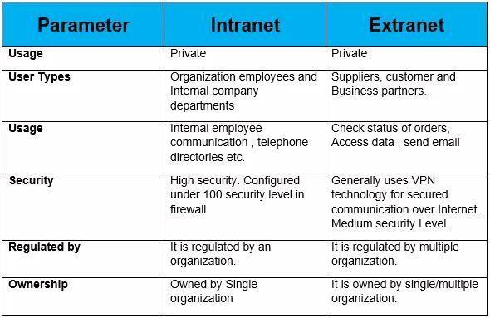

|  |  |
| --- | --- |
|  |  |
|  |  |
|  |  |

BENEFITS OF INTRANET & EXTRANET!

THANK YOU!!

* 1. (107)Sparsh Shah / (04)Krish Chanchad
* 2. (85)Aniket Shukla
* 3. (144)Meet Mendapara
* 4. (110)Roshini Singh
* 5. (68)Vivek Purohit
* 6. (125)Stuti Limbachaiya
* 7. (09)Harsh Davra
* 8. (43)Krish Menat
* 9.(74)Mustakim Sayyed